
Assignment Cover Sheet
Subject Code: | CSIT321
Subject Name: | Project
Submission Type: | Report (Online Submission)
Assignment Title: | Planning and Feasibility Analysis Document

Student Name: | Student Number: | Student Phone/Mobile No. | Student E-mail:
Mohamed Shafeen | 8303988 | +971 50 697 7256 | mbmlm997@uowmail.edu.au
Sibi Varghese | 8935166 | +971 56 769 2609 | svp967@uowmail.edu.au
Wissam Musba | 8973465 | +971 50 669 1375 | wm932@uowmail.edu.au
Muhammad Yahya | 8258168 | +971 50 360 4425 | my285@uowmail.edu.au
Hriday Kumar | 8890766 | +971 55 351 1809 | hpk687@uowmail.edu.au

Lecturer Name: | Professor May El Barachi
Due Date: | 29/10/2026
Date Submitted:

PLAGIARISM:  The penalty for deliberate plagiarism is FAILURE in the subject. Plagiarism is cheating by using the written ideas or submitted work of someone else. UOWD has a strong policy against plagiarism.  The University of Wollongong in Dubai also endorses a policy of non-discriminatory language practice and presentation.  PLEASE NOTE: STUDENTS MUST RETAIN A COPY OF ANY WORK SUBMITTED | DECLARATION:  I/We certify that this is entirely my/our own work, except where I/we have given fully-documented references to the work of others, and that the material contained in this document has not previously been submitted for assessment in any formal course of study. I/we understand the definition and consequences of plagiarism. We/I declare that the project proposal has not been used in any UOWD courses before and that this project idea is a total new idea of the project team.  Signature of Student:

Optional Marks:
Comments:

Lecturer Assignment Receipt (To be filled in by student and retained by Lecturer upon return of assignment)
Subject: CSIT321 Project | Assignment Title: Planning and Feasibility Analysis Document
Student Name: Mohamed Shafeen; Sibi Varghese; Wissam Musba; Muhammad Yahya; Hriday Kumar | Student Number: 8303988; 8935166; 8973465; 8258168; 8890766
Due Date: 29/10/2026 | Date Submitted:
Signature of Student:

Student Assignment Receipt (To be filled in and retained by Student upon submission of assignment)
Subject: CSIT321 Project | Assignment Title: Planning and Feasibility Analysis Document
Student Name: Mohamed Shafeen; Sibi Varghese; Wissam Musba; Muhammad Yahya; Hriday Kumar | Student Number: 8303988; 8935166; 8973465; 8258168; 8890766
Due Date: 29/10/2026 | Date Submitted:
Signature of Lecturer:

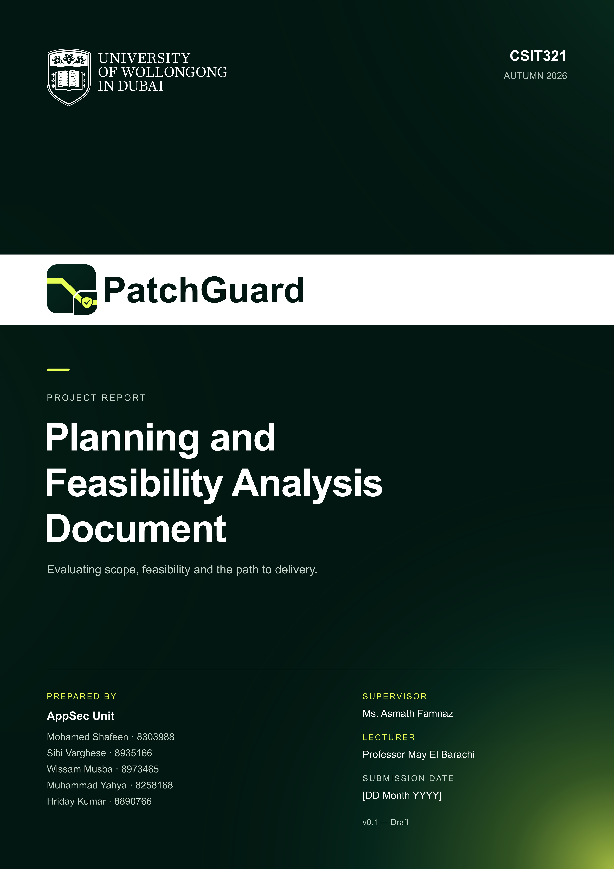
Table of Contents
1 Background and Problem Statement 1
2 Project Description and Objectives 2
2.1 Proposed Solution 2
2.2 Objectives and Success Criteria 3
3 Competitor Analysis and Business Case 5
3.1 Existing Solutions and Their Limitations 5
3.2 Feature Comparison and SWOT 6
3.2.1 Feature Comparison 6
3.2.2 SWOT Analysis 7
3.3 Target Niche and Proposed Value 8
4 Project Scope 8
4.1 Features and Exclusions 8
4.1.1 Features in scope 8
4.1.2 Exclusions 10
4.2 Prerequisites and Limitations 10
5. System Architecture and Operation 11
5.1 System Overview 11
5.2 Architecture and Components 11
5.3 System Workflow 13
5.4 Interface Descriptions 14
6. Resources and Technology Selection 15
6.1 Hardware and Execution Environments 15
6.2 Software Technologies and Selection Justification 15
6.3 External Services (confirm with wissam) 16
7 Feasibility Analysis 17
7.1 Technical and Operational Feasibility 17
7.2 Costs and Budget 17
7.3 Time and Team Capacity 17
8 Challenges and Risk Management 18
9 Project Plan and Work Distribution 19
9.1 Timeline and Gantt Chart 19
9.2 Project Management Approach and Tools 21
9.3 Team Responsibilities and Contributions 22
10 Future Improvements and Conclusion 23
11 Report Work Distribution 24
References 25

1 Background and Problem Statement
Today’s software development landscape has a major gap between AppSec and delivery velocity, with Continuous Integration and Continuous Deployment (CI/CD) pipelines, microservices, and AI-assisted coding. Organisations continuously deploy code changes, but security verification does not occur within the developers’ workflow. The percentage of applications with vulnerabilities in custom, first-party source code, out of all applications analyzed (both large and small businesses, commercial software suppliers, software outsourcers, and open-source applications), is about 63% (Veracode, 2024). Therefore, 71% of organisations have “security debt” (flaws that have not been remediated for over a year), and nearly 90% of this security debt is located in first-party code (Veracode, 2024). Production web apps and APIs, where injection vulnerabilities are the most prevalent, are therefore always vulnerable to preventable vulnerabilities (Edgescan, 2023). This is because of the noise in diagnosis and the long lag time in remediation.
Static Application Security Testing (SAST) tools use static pattern heuristics against the source code without executing the application, but they also produce a lot of false positives, causing developers to ignore the actual bugs and accept false alarms from the analyzer (Bessey et al., 2010). To maintain developer trust, program analysers are advised to limit the rate of false positives to 15%–20% (Christakis and Bird, 2016). At Google, bug dashboards that were not part of the day-to-day business were bypassed, and only 16% of the warnings found in a FindBugs campaign were patched (Sadowski et al., 2018). Manual reachability triage can potentially cause remediation delays. The Mean Time to Remediate (MTTR) of critical vulnerabilities is 65 days for the entire stack and 73.9 days for the web application and API layer (Edgescan, 2023).
Functional regressions can occur when modifying first-party business logic. Automated dependency bots such as GitHub Dependabot update only the manifests of vulnerable third-party packages across language ecosystems (GitHub, n.d.c), and chat-based AI coding assistants do not have feedback from runtimes. When the benchmark was released in 2024, the best-performing model in SWE-bench was able to solve only 1.96% of the issues found in real-world GitHub repositories without failing the unit tests (Jimenez et al., 2024).
Therefore, no single, closed-loop exploit remediation solution currently exists that can automatically detect and fix exploits in an isolated container sandbox, self-heal across context-aware fixes for various polyglot web frameworks, and run self-healing regression tests before sending pull requests to human users for review.

2 Project Description and Objectives

2.1 Proposed Solution
PatchGuard is an autonomous, closed loop DevSecOps remediation agent designed to close the gap between static vulnerability detection and verified code remediation. It's not some passive alerting scanner or unverified chatbot. It's an end-to-end pipeline which will assess exploitability, generate secure source code fixes for polyglot web apps and then enforce a zero-regression test gate before presenting the engineer with a PR that they can actually merge.
PatchGuard integrates vulnerability discovery and remediation through a structured six-stage continuous remediation lifecycle:
- Automated ingestion and static taint analysis: Performed via CI/CD commit webhooks or a developer CLI. PatchGuard uses the Semgrep Community Edition scanner to perform AST taint tracking across the codebase. It follows untrusted user input from entry points to sensitive execution sinks, identifies high risk vulnerability patterns (e.g. injection flaws) and outputs the findings in a standard JSON format.
- Ephemeral Sandboxed Exploit Verification: To reduce the diagnostic noise and false positives, PatchGuard provides an isolated, ephemeral Docker reproduction container which reproduces the repository's runtime environment in seconds. A non-destructive, benign PoC probe (e.g. a simple SQL boolean check or timing probe) is run against the app. If the vulnerability cannot be triggered at runtime it is logged and dropped. This prevents alert fatigue and ensures that only genuine vulnerabilities get to the repair stage.
- Agentic Program Repair: Having established via empirical testing that a vulnerability was exploitable, an AI patch agent (orchestrated via LangGraph) then goes on to analyse the vulnerability AST path, the relevant function logic and project dependencies. Using strict Pydantic schemas the agent will then prompt an LLM to generate a minimal, context aware code patch which conforms to the established secure coding guidelines (parameterisation, schema validation etc).
- Zero Regression Verification and Self-Healing: The patch is applied in a dedicated verification container where the existing automated test suite for the repository (Pytest, Jest, Vitest, PHPUnit, RSpec, Go Test etc.) is run along with a re-run of the exploit check. If the exploit is still present or any of the functional tests fail (i.e. a regression has occurred) then the runtime error traceback is provided to the LangGraph agent as part of an iterative self-healing loop. The agent will then analyse the failure and improve the code (up to 3 attempts) until the patch passes all the functional tests.
- Interactive Review and "Hack-Your-Own-Patch" Playground: Verified findings and execution telemetry are pushed in real time to Google Firebase Firestore and displayed in a responsive Next.js web dashboard. In addition to the standard side-by-side Monaco code diff (red/green view) you get an interactive testing console where you can submit your own exploit payloads or kick off an AI Red-Team auto-fuzzer to watch the runtime response of both the unpatched and patched container at the same time.

- Governed GitHub Pull Request deployment: In order to maintain the strict developer in the loop governance we have, PatchGuard will not automatically push changes to production. The engineer will review the diff, inspect the sandbox evidence and approve the change. The GitHub integration will then create a dedicated branch and open an automated Pull Request which will contain the exploit proofs and the regression test logs.

2.2 Objectives and Success Criteria
PatchGuard is intended to show that autonomous multi-agent systems can safely detect and patch real world application vulnerabilities without causing any functional regressions. The project objectives and criteria for success have been defined in accordance with the SMART (Specific, Measurable, Achievable, Relevant, Time-bound) framework to ensure that the evaluation is rigorous throughout the two-semester capstone.
- Objective 1: Automated Vulnerability Detection and Taint Normalization
Develop a static analysis pipeline using the Semgrep Community Edition to parse the repository source code and extract the source-to-sink dataflow paths in a standard JSON format.
- Success criteria: Static scans to be completed in under 5 seconds on codebases of up to 10,000 lines of code and all issues detected to be correctly mapped to the relevant CWE (Common Weakness Enumeration) for all supported web frameworks.
- Objective 2: Empirical False-Positive Elimination via Sandboxing
Construct an isolated execution harness using the Docker Python SDK to provision disposable container replicas for dynamic testing of vulnerability reachability using non-destructive probes.
- Success criteria: Spin up containers in under 2 seconds and tell real, exploitable flaws apart from false alarms with over 90% accuracy on benchmark testbeds.
- Objective 3: Context-Aware Program Repair and Zero-Regression Verification
Develop an agent-based repair workflow using LangGraph and advanced LLMs to generate minimal syntax patches and validate those against the existing unit test suite in the repository as part of an automated reflection loop.
- Success criteria: Greater than 80% remediation success rate on the target vulnerability types (SQLi, command injection, path traversal etc.), 100% regression pass rate (i.e. no PRS will be generated if any of the existing unit tests fail) and self-healing convergence within a maximum of 3 retry iterations.
- Objective 4: Polyglot Multi-Language Extensibility
Design a modular container dispatcher which can detect the programming language of the target repository and dispatch to the appropriate runtime container and native test runner.
- Success criteria: carry out the end-to-end remediation workflow across the six-target web and systems ecosystems (Python (pytest), JavaScript (jest), TypeScript (vitest), PHP (phpunit), Ruby (rspec) and Go (go test)).
- Objective 5: Interactive Human-in-the-Loop Review and Live Exploit Playground
Build a developer command dashboard (Next.js 15, Tailwind CSS and Monaco Editor) with real time audit persistence via Google Firebase Firestore.
- Success criteria: keep the database sync latency below 500ms (from backend completion to frontend render), provide sub-second side by side diff view and enable real time execution of custom user payloads against both containers in the "Hack-Your-Own-Patch" playground console.
Objective 6: Remediate the Operational Workability and Pipeline Performance
Integrate the complete remediation cycle into the developer and CI/CD workflows (both CLI and GitHub Actions) with very low execution latency and zero cost.
- Success criteria: Achieve a mean closed loop cycle time of under 60 seconds from scan initiation to PR creation for a typical repository commit and keep total external cloud spend at $0.00 by using the Google Firebase Spark free tier and running locally or on free tier execution environments.

3 Competitor Analysis and Business Case

3.1 Existing Solutions and Their Limitations
In this section we will review existing products that directly rival our own, then compare their features with PatchGuard’s. We will also examine what the comparison reveals about PatchGuard’s strengths, weaknesses, opportunities, and threats. Together, these comparisons show where PatchGuard could offer a useful advantage and what challenges the project will need to address.
Snyk Code
What it is: Snyk Code is a static application security testing (SAST) tool that finds security issues in source code and fits into IDE, CLI, CI/CD, and source-control workflows. It also offers AI-assisted Agent Fix suggestions for Snyk Code findings. The product supports many languages, including Python (Snyk, n.d.a, n.d.b, n.d.c).
Limitations. Snyk Code finds vulnerabilities and can suggest fixes. Snyk Code finds vulnerabilities and can suggest fixes. However, its documented workflow does not include a disposable runtime sandbox to confirm exploitability or require the repository’s test suite to run before a fix is accepted (Snyk, n,d,b).
Target niche: Developer and application-security teams that need broad, multi-language SAST in IDE, repository, and CI workflows, particularly teams already using the Snyk platform.
GitHub Copilot Autofix for CodeQL alerts
What it is: GitHub Copilot Autofix suggests code changes and explains them for supported security alerts detected by CodeQL. Because it is built into GitHub code scanning, developers can review the suggestion alongside the alert in their repository and pull request (GitHub, n.d.a, n.d.b).
Limitations: Autofix covers only selected CodeQL queries and languages. For supported alerts, GitHub checks a suggestion by running CodeQL again, but this does not test the application’s behaviour or replace the repository’s own test suite. GitHub recommends reviewing and testing suggestions before merging, since generated changes may contain syntax or semantic errors (GitHub, n.d.a, n.d.b).
Target niche: It is aimed at teams that host code on GitHub and use CodeQL or GitHub Code Security, particularly those who want fix suggestions within their existing code-scanning and pull-request process.

Semgrep Autofix
What it is: Semgrep Autofix provides remediation guidance and AI-generated fix suggestions for Semgrep Code findings in pull requests. It also offers breaking-change analysis and upgrade guidance for dependency updates. In March 2026, Semgrep described Autofix as a public beta and noted that code fixes could be triggered through an API (Semgrep, 2026a).
Limitations: Semgrep’s published description centres on static findings and recommended changes. It does not describe a built-in sandbox that tests whether a vulnerability can be exploited or a required run of the project’s test suite before a fix is offered. Autofix was in public beta in March 2026, and AI autofixes use credits under Semgrep’s usage model (Semgrep, 2026a, 2026b).
Target niche: It is suited to application-security and engineering teams that already use Semgrep to scan code, triage findings, and manage remediation through pull requests or related security workflows.

3.2 Feature Comparison and SWOT

3.2.1 Feature Comparison
The table compares capabilities that matter to PatchGuard’s planned workflow, from finding a vulnerability to checking a proposed fix. PatchGuard’s check marks represent features in the approved design that still need to be implemented and evaluated. The competitor entries reflect capabilities described in the vendors’ documentation (GitHub, n.d.a, n.d.b; Semgrep, 2026a, 2026b; Snyk, n.d.a, n.d.b, n.d.c).
Table 3.2.1 Competitor features comparison
Feature | PatchGuard (Planned) | Snyk Code | GitHub Copilot Autofix | Semgrep Autofix
Static code / data-flow vulnerability analysis | ✓ | ✓ | ✓ | ✓
Ai-generated security fix suggestion | ✓ | ✓ | ✓ | ✓
Disposable runtime sandbox to verify exploitability | ✓ | — | — | —
Run the repository’s existing test suite on the patch before approval | ✓ | — | — | —
Iteratively revise the patch using failed-test output | ✓ | — | — | —
Can analyse python web code | ✓ | ✓ | ✓ | ✓
Human-reviewed change delivered through a pull-request workflow | ✓ | ✓ | ✓ | ✓
Per-finding exploit and regression-test evidence | ✓ | — | — | —
The table highlights the capabilities PatchGuard is planned to combine static analysis, runtime checks for exploitability, patch generation, and testing against the repository’s existing test suite. These are planned features, not evidence that the system is already working. The prototype will need to demonstrate its sandbox controls, tests, and end-to-end results. The competitor columns show features documented as part of each product. Teams may add test suites or custom integrations around those products, but those additions are not counted in this comparison.

3.2.2 SWOT Analysis
This SWOT consolidates what the competitor review means for PatchGuard. Strengths and weaknesses are internal to the proposed project; opportunities and threats describe external conditions.
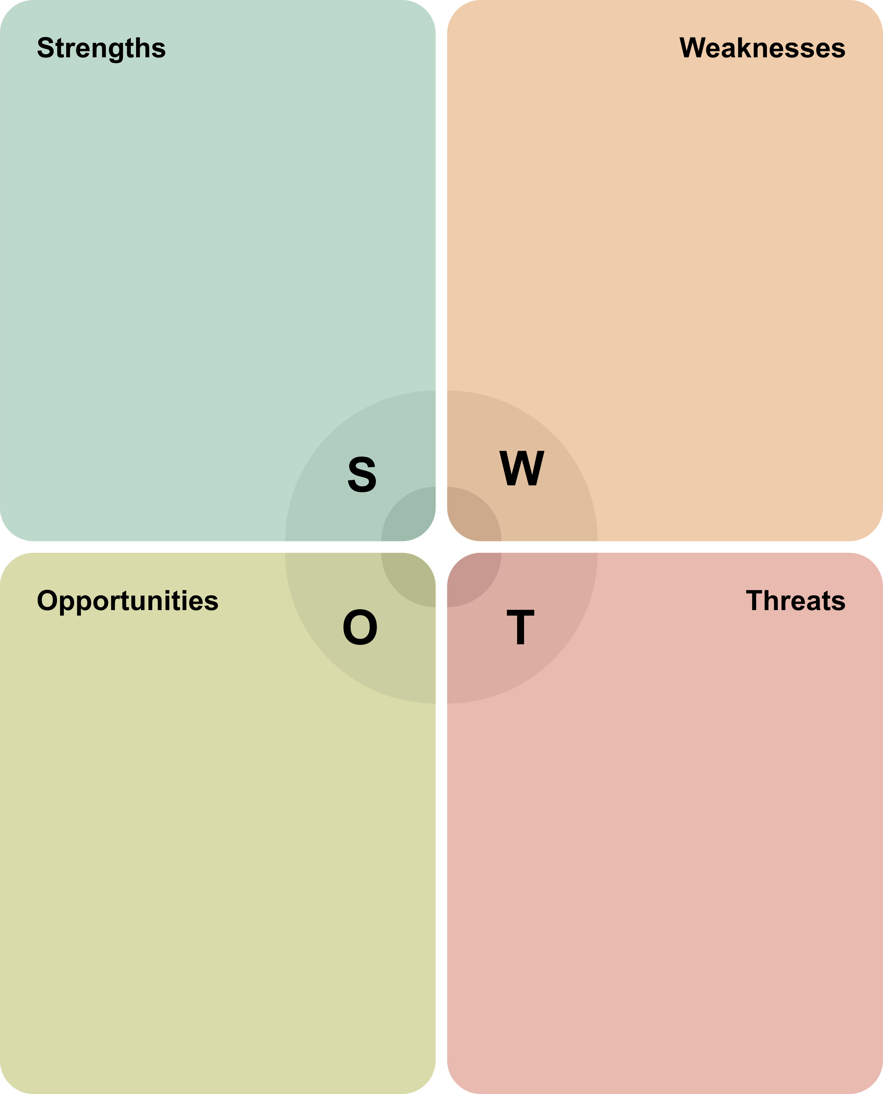
• PatchGuard is designed to bring static taint analysis, a non-destructive runtime check, patch generation, and regression testing into one workflow.  • Human approval and GitHub pull requests keep developers involved in the final decision.  • The planned support for Python, JavaScript, TypeScript, PHP, Ruby, and Go could make the workflow useful for teams maintaining mixed-language web systems. |  | • Supporting six languages within a two-trimester capstone creates implementation and validation complexity; depth and consistency may vary between ecosystems.  • The system depends on Docker and external LLM APIs, which can affect setup, cost, response time, and data handling.  • Exploit checks and passing tests cannot prove that a patch is secure in every context. The capstone will need to measure effectiveness rather than assume there will be no false positives or regressions.
• Engineering and DevSecOps teams working across the six planned languages may value a workflow that connects security findings with runtime and test evidence.  • A lightweight CLI and CI workflow could offer an initial way to use the system while the planned dashboard and GitHub app are developed.  • Testing against 25 public CVE repositories across Python and JavaScript could provide measured results for remediation, regressions, and latency.  • Regional fintech and software teams may value reviewable evidence to support security decisions. |  | • Snyk, GitHub, and Semgrep already have established developer adoption, integrations, and investment in AI-assisted remediation. They could add verification features over time.  • An unsafe exploit probe, sandbox escape, or patch that introduces a regression could damage user trust.  • API costs, model availability, repository permissions, and security policies could limit enterprise use.  • A small capstone team may not have enough time to harden and maintain the system to production standards.

Figure 3.2.2 SWOT analysis chart

3.3 Target Niche and Proposed Value
Target niche: PatchGuard is aimed at software engineering and DevSecOps teams that handle security findings in local development environments or CI/CD pipelines. The proposed deployment environments include GitHub Actions, GitLab CI, local developer workstations, and enterprise DevSecOps centres. Its planned analysis and remediation workflow covers Python, JavaScript, TypeScript, PHP, Ruby, and Go, with language-specific container and test-runner support.
Proposed value: PatchGuard is designed to connect a static security finding to a proposed fix supported by runtime and test evidence across its six planned languages. Semgrep traces potentially unsafe data flows, then an isolated Docker sandbox checks whether a benign probe can trigger the finding. If it can, PatchGuard generates a patch and runs the repository’s corresponding test suite: Pytest, Jest, Vitest, PHPUnit, RSpec, or Go Test. Test failures can feed back into the repair loop. Developers can review the code diff and verification evidence before approving a GitHub pull request. This workflow aims to reduce time spent on triaging findings and give teams more information when assessing AI-generated fixes, with its effectiveness still to be measured in the prototype.
PatchGuard is also planned to include an interactive hack simulation where developers can submit custom payloads and compare responses from unpatched and patched containers. The planned polyglot container dispatcher will select a runtime for the repository’s supported language. Scan records and verification evidence would be stored in Firebase Firestore, giving teams results they can review later. The playground is intended to make the effect of a patch easier to understand while keeping the final decision with the developer. These are planned capabilities.

4 Project Scope

4.1 Features and Exclusions
The capstone describes a two-trimester prototype of an automated vulnerability verification and remediation system. The first trimester focuses on the analysis and repair engine, while the second trimester adds multilingual dispatch, web review, and evaluation. The following scope details what is included and excluded from the proposed project deliverables.

4.1.1 Features in scope
Analysis and exploit verification: Semgrep is used to trace tainted code in Python, JavaScript, TypeScript, PHP, Ruby, and Go, and PatchGuard exploits benign proof-of-concept probes in disposable Docker containers to verify reachability.
Patch synthesis and regression testing: a LangGraph agent is used to propose a minimal viable patch in the language of the repository, which then undergoes testing with the relevant test-suite (Pytest, Jest, Vitest, PHPUnit, RSpec, or Go test). In the case of test-suite failures, a self-healing mechanism with up to three patch retries is initiated.
Command-line tool and initial prototype (Trimester 1): a standalone command-line interface (CLI) is created to execute the remediation workflow, which outputs a .patch file. An interactive prototype is built with Figma to demonstrate finding triage, developer review, and code-diff inspection. A FastAPI service and Firebase Firestore are also set up as the foundation for the later web application.
Polyglot runtime and web review (Trimester 2): a docker dispatcher is created that detects the language of the repository and initiates the relevant runtime inside a container. A Next.js dashboard is also developed to visualize scan progress and audit trails, with Firestore supporting database operations and storage while Firebase Auth handles user authentication. Monaco is also deployed to review multi-language diffs within the dashboard.
Interactive testing and GitHub workflow (Trimester 2): a “hack-your-own-patch” playground is developed where users can compare the responses of an unpatched and a patched container, optionally with an AI-generated red-team probe. The GitHub application then launches a pull request with the exploit proof and test logs after a user reviews a suggested patch.
Evaluation (Trimester 2): the performance of PatchGuard is benchmarked against 25 downstream CVE repositories in Python and JavaScript, assessing the number of successfully remediated findings, regression rate, and overall performance.

4.1.2 Exclusions
The analysis of C and C++, Rust, or low-level assembly is outside the scope of this project.
PatchGuard is not designed to directly commit changes to a repository’s default or production branches. Instead, there should be a human gatekeeper who reviews the proposed changes in a pull request before merging them into the production branch.
This project does not involve training or fine-tuning any language models. Instead, it focuses on using existing hosted models via prompt-engineering and orchestration with LangGraph.
PatchGuard is not a general-purpose binary fuzzer but instead focuses on targeted vulnerability verification and remediation based on high-level analysis of abstract syntax trees (AST).
All probes used for testing should be benign and non-destructive and executed in an isolated Docker environment. Testing destructive payloads or directly probing production or third-party applications is beyond the scope of this project.

4.2 Prerequisites and Limitations
Prerequisites: The team needs a foundation in application security, web development, REST APIs, Git and GitHub, and software testing. The implementation also requires Python, Semgrep, Docker, LangGraph, and experience using hosted language-model APIs. Team members will need to configure Firebase and the language-specific runtimes and test tools used by the prototype.
A scan can be completed only if the target repository uses a supported language and its dependencies can be installed in the matching Docker container. PatchGuard also needs the repository’s supported test runner to check a proposed fix. Cloud features require network access, Firebase configuration, and credentials for the selected language-model API. Creating a GitHub pull request requires repository permissions and human approval.
Limitations: PatchGuard is a capstone prototype, so its coverage scope will be limited by what vulnerability patterns and frameworks are recognized by its Semgrep rules and runtime probes. The proposed assessment will be executed on 25 real-world CVE repositories representing all six planned languages to evaluate the remediation success rate, regression rate, and latency. Since the evaluation will be based only on these repositories, the results will not prove the tool’s ability to handle all projects and vulnerabilities in these ecosystems but highlight the capabilities of the prototype.
If a benign probe fails to reproduce the finding, that does not necessarily mean the finding is benign. The fact that it passed the repository’s tests only confirms behaviors covered by those tests. It does not establish that the patch is entirely safe and without regressions. One should always carefully review proposed patches and make sure that sandbox tests are limited and controlled. The prototype has some serious limitations in terms of requirements.
The tool is built upon Docker, language-model APIs, Firebase, and access to the target repository. All of these components could fail at any given moment, cause issues with permissions, response rate, billing, or other factors leading to an interruption or failure of a scan. The prototype would need additional improvements and a thorough security audit before it can be considered production ready.

5. System Architecture and Operation

5.1 System Overview
PatchGuard is a closed loop vulnerability remediation tool that is used to scan web applications written in Python, JavaScript/TypeScript, PHP, Ruby, and Go. Potential vulnerabilities are run in an isolated Docker container to see if they are exploitable. An AI agent is then used to create the security patches for confirmed vulnerabilities. The proposed patches are validated with the existing tests at the repository and if there are some failures, the agent goes back and makes improvements to the patch. Developers can check the patches and verification results, test more payloads in a playful interactive playground (optionally), and approve the submission of the GitHub pull request.

5.2 Architecture and Components
Figure 5.2 PatchGuard system architecture

Table 5.2 System components and responsibilities
No. | Component | Technology | Responsibility | Input → Output
01 | Web Dashboard | Next.js 15, Tailwind CSS, Monaco Editor | Displays vulnerability findings, scan results, code differences and provides an interactive testing interface. | Scan findings and updates → Developer review and actions
02 | Backend Gateway | FastAPI | Manages scan requests, coordinates system components and stores results in Firebase. | Scan request → Scan results and status
03 | Vulnerability Scanner | Semgrep Community Edition | Analyzes source code to identify potential security vulnerabilities across six supported programming languages. | Source code → Potential vulnerabilities
04 | Reproduction Container | Docker | Tests detected vulnerabilities in an isolated environment to determine whether they can be exploited. | Potential vulnerability → Exploit verification result
05 | AI Patch Agent | LangGraph, Pydantic, Cloud AI APIs | Generates security patches and improves them using feedback from verification tests. | Verified vulnerability and test feedback → Proposed security patch
06 | Verification Container | Docker, Native Test Suites | Checks whether the generated patch addresses the vulnerability and runs regression tests to identify unintended changes. | Proposed patch → Verification and test results
07 | Developer Approval Gate | Human Review | Allows developers to review proposed patches and verification evidence before approving or rejecting them. | Patch, code differences and test results → Approval or rejection
08 | GitHub Integration | GitHub App | Receives repository events and creates branches and Pull Requests for approved patches. | Approved patch → GitHub Pull Request
– | Data Store | Firebase Firestore & Authentication | Stores vulnerability findings, patch history and audit records while supporting user authentication and dashboard updates. | Scan and patch records → Stored data and dashboard updates

Trust Boundaries
- Isolated Sandbox: Docker containers isolate vulnerability testing and patch verification from the main system, lessening the risk of running potentially unsafe code.
- Safe Exploit Testing: PatchGuard will perform non-destructive test payloads to test whether there can be any vulnerability to exploit if there is any limitation on the operations that are harmful.
But before any of these changes are submitted as a Pull Request on GitHub, they are reviewed and approved by developers as part of the process of Human Approval. PatchGuard does not automatically merge changes into the main production branch.

5.3 System Workflow
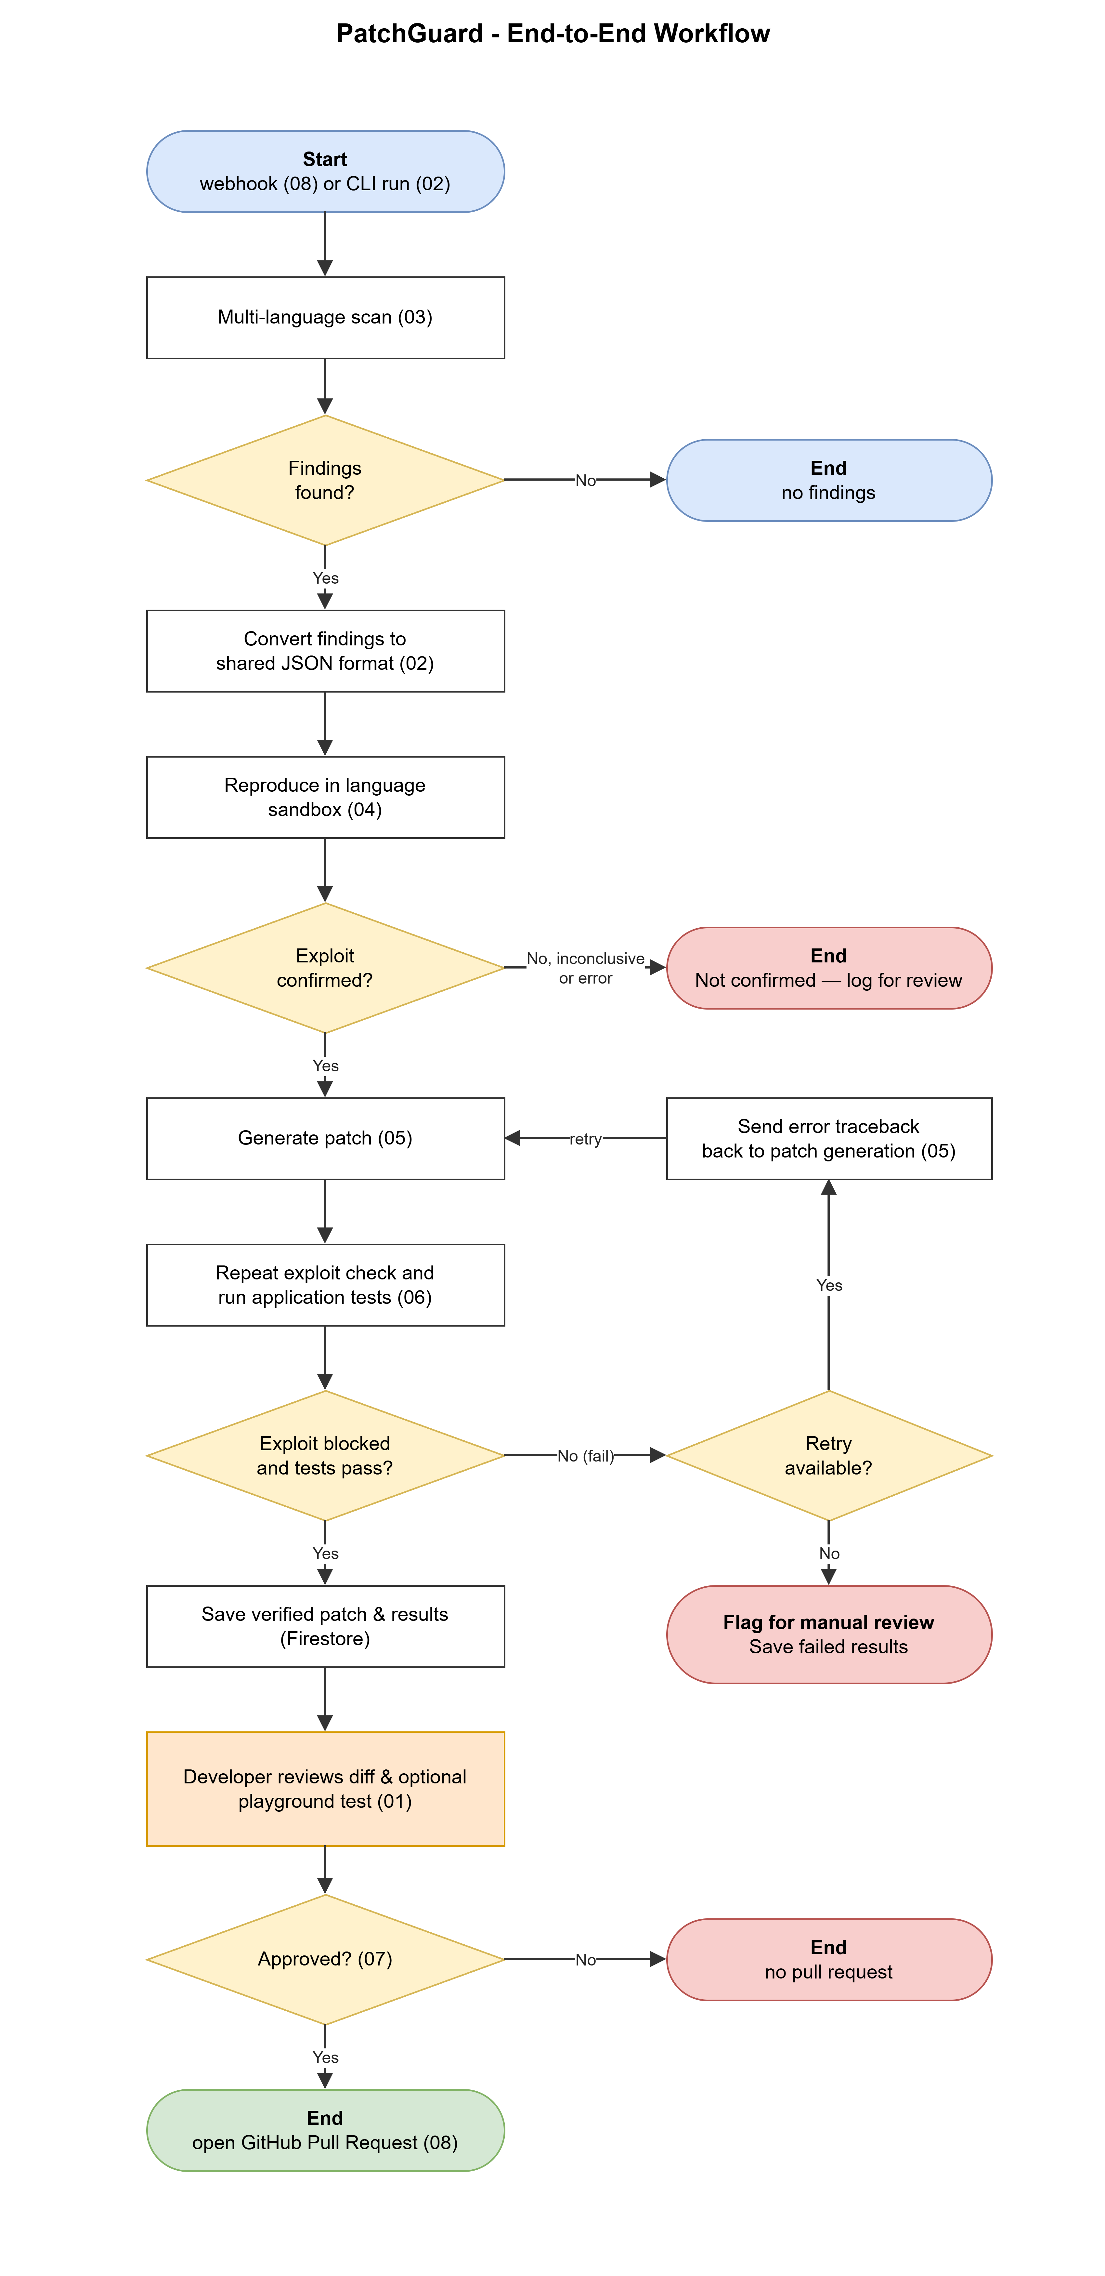
Figure 5.3 PatchGuard end-to-end workflow

Table 5.3 System workflow steps
Step | Component | What happens
1 | 08, 02 | A GitHub webhook or command-line request initiates a vulnerability scan.
2 | 03, 02 | Semgrep scans the source code and converts detected findings into a common JSON format.
3 | 04 | Potential vulnerabilities are tested in an isolated Docker sandbox. Findings that cannot be confirmed are logged.
4 | 05 | The AI agent generates a patch for each confirmed vulnerability.
5 | 06 | The patch is checked for effectiveness, and the project's existing tests are executed.
6 | 06, 05 | If verification fails, the results are returned to the AI agent for another attempt. Unsuccessful patches are flagged for manual review.
7 | 06, 02 | Verified patches and test results are stored in Firebase Firestore.
8 | 01 | The developer reviews the patch and test results through the dashboard, with the option to perform additional testing.
9 | 07 | The developer approves or rejects the proposed patch.
10 | 02, 08 | Once approved, the GitHub integration creates a branch and opens a Pull Request with supporting verification results.

5.4 Interface Descriptions
Table 5.4 Component interfaces and communication methods
Interface | Between | Protocol / format
Dashboard to Backend | 01 ↔ 02 | REST API, JSON
GitHub Webhook | 08 → 02 | GitHub Webhook
Command-Line Interface | Developer → 02 | CLI
Component Data Exchange | 02, 04, 05, 06 | JSON
Container Management | 02 ↔ 04, 06 | Docker Python SDK
Patch Verification | 05 ↔ 06 | Patch Data and Test Results
Verification Results | 06 → 02 | JSON Results
AI Model Communication | 05 ↔ Cloud AI API | Cloud API
Database Communication | 02 ↔ Firestore; Firestore → 01 | Firebase SDK, Real-Time Updates
GitHub Integration | 02 ↔ 08 | GitHub App API

6. Resources and Technology Selection

6.1 Hardware and Execution Environments
Table 6.1 Hardware requirements and execution environments
Resource | Specification | Used for
Developer Workstations | Standard student laptops with approximately 16 GB RAM, supporting Python, Docker, and development tools. | Software development, local testing, and sandbox execution.
Docker Sandbox Containers | Lightweight, isolated containers for Python, JavaScript, TypeScript, PHP, Ruby, and Go, with controlled resource usage. | Vulnerability reproduction, patch verification, and regression testing.
Target Environments | Local developer workstations, CI/CD pipelines (GitHub Actions and GitLab CI), and enterprise DevSecOps environments. | Running PatchGuard locally and integrating it into software development workflows.

6.2 Software Technologies and Selection Justification
Table 6.2 Software technologies and selection rationale
Category | Chosen tool | Justification
Core Language | Python 3.10+ | Supports Backend development, AI orchestration, static analysis integration and Docker container management.
Frontend Language | TypeScript 5.0+ | Improves maintainability of the web dashboard and provides type safety.
Static Code Analyzer | Semgrep Community Edition | Static analysis with syntax awareness to find potential vulnerabilities in all six supported programming languages.
AI Orchestration | LangGraph (Python) | Is able to handle the creation of AI patches and facilitate incremental improvements in light of verification feedback
Data Validation | Pydantic v2.0+ | Checks and audits AI output structures for data consistency among system components
Foundation Models | Claude 3.5 Sonnet, GPT-4o, Gemini Flash | Develop knowledge in coding and security reasonings for vulnerability analysis and automatic patch generation.
Containerization | Docker Engine and Docker Python SDK | Ensures isolated environment for vulnerability re-creation, patch verification and regression tests.
Regression Testing | Pytest, Jest, Vitest, PHPUnit, RSpec, Go Test | Runs and observes running of current project tests to detect regressions caused by security patches.
Backend Framework | FastAPI | Supports RESTful APIs to manage and communicate between system elements asynchronously.
Database | Firebase Cloud Firestore | Stores vulnerability, scan, patch and audit logs; supports real-time dashboards.
Authentication | Firebase Authentication | Enables secure team sign-in via Google Sign-In and/or email and password.
Frontend Framework | Next.js 15 | `Provides dashboard for review of scan results, as well as examination of proposed patches using react.
Styling Framework | Tailwind CSS 3.4+ | Facilitates responsive website design and uniform dark/light themes.
Code Diff Editor | Monaco Editor | Compares and highlights side-by-side for developer review.

6.3 External Services
Table 6.3 External services and proposed service plans
Service | Use | Plan
Cloud LLM APIs (Claude 3.5 Sonnet, GPT-4o, Gemini Flash) | Vulnerability analysis and automated patch generation. | Cloud APIs
Firebase (Firestore and Authentication) | Stores scan results, supports user authentication, and provides real-time dashboard updates. | Spark Plan (Free)
GitHub | Supports repository webhooks, branch creation, and Pull Request submission after developer approval. | GitHub App

7 Feasibility Analysis

7.1 Technical and Operational Feasibility
The feasibility of PatchGuard has been systematically evaluated across its four core technical subsystems and operational deployment workflows to confirm viability within a two-trimester timeline.
Table 7.1 Technical and operational feasibility assessment
Subsystem / Technology | Feasibility Parameter | Empirical / Benchmark Evidence | Verdict
Static Taint Analysis  (Semgrep Community CLI) | Scan latency & AST taint-tracking accuracy across 6 languages. | Semgrep evaluates 20,000–50,000 LOC/sec. Repositories under 10,000 LOC scan in < 2.5s, identifying untrusted source-to-sink dataflows directly from source files without database build overhead. | High Feasibility
Polyglot Sandboxing  (Docker Python SDK) | Container startup latency & safe runtime execution across 5 runtimes. | Using pre-cached alpine/slim images (Python, Node, PHP, Ruby, Go), containers boot via the Polyglot Dispatcher in < 2.0s with read-only filesystems, 512MB RAM caps, and non-routable internal bridge networks. | High Feasibility
Multi-Agent Reasoning  (Mimi 2.6 Flash / DeepSeek 4.1 Flash / MuseSpark 1.3) | Output schema adherence, exploit proofing, and syntactic patch generation. | High-speed reasoning models deliver sub-second generation times. Pydantic v2 schemas ensure near-100% JSON contract compliance and > 80% first-pass syntactic validity on security patches. | High Feasibility
Zero-Regression Gates  (Pytest, Jest, Vitest, PHPUnit, RSpec, Go Test) | Automated test suite execution and stack-trace reflection. | Native repository test suites execute inside containers in 3–6s. Assertion errors and tracebacks are captured via JSON report flags and reflected into LangGraph for automated self-healing. | High Feasibility
Cloud Data Persistence  (Firebase Firestore) | Real-time scan persistence and web dashboard synchronization. | Cloud Firestore natively stores JSON vulnerability contracts. WebSocket subscriptions (onSnapshot) sync scan status and test diffs to Next.js in < 100ms. | High Feasibility

7.2 Costs and Budget
PatchGuard leverages high-efficiency AI reasoning models alongside open-source frameworks and free cloud tiers to achieve zero external cloud infrastructure costs.
Cost Assumptions:
• Target evaluation dataset: 30 real-world CVE benchmark repositories evaluated across Trimesters 1 and 2.
• Token usage per incident: ~1,500 prompt / 500 completion tokens for exploit synthesis; ~2,500 prompt / 800 completion tokens for patch synthesis (capped at 3 reflection retries).
• Total lifecycle tokens: ~8,000,000 prompt tokens and ~2,500,000 completion tokens.
• Model pricing (Mimi 2.6 Flash / DeepSeek 4.1 Flash / MuseSpark Contributor 1.3): Blended rate of ~$0.25/1M input and ~$0.85/1M output tokens (~15.25 AED / ~$4.15 USD total inference).
• Database & Web: Google Firebase Spark Free Tier ($0) and Vercel Hobby Tier ($0).
• Hardware: Personal developer workstations running Docker Desktop on Windows 11/macOS/Linux.
Table 7.2 Itemized project budget and resource expenditure
Resource Category | Item & Technical Specification | Quantity / Usage | Unit Cost | Total (AED) | Total (USD)
AI Inference APIs | Mimi 2.6 Flash, DeepSeek 4.1 Flash, MuseSpark 1.3 | ~8M input / 2.5M output tokens | Pay-per-token API tier | ~16 AED | ~$4.35
Static Code Analysis | Semgrep Community Edition (CLI Engine) | Unlimited multi-language scans | Open Source (LGPL 2.1) | 0 AED | $0.00
Container Sandbox | Docker Community Engine & Python SDK | 5 developer workstations | Free Educational / OSS | 0 AED | $0.00
Backend API Gateway | FastAPI Framework + Python 3.10 | Unlimited API routes | Open Source (MIT) | 0 AED | $0.00
Cloud Data & Auth | Google Firebase (Firestore & Authentication) | Spark Plan (Free Tier) | Free Cloud Tier ($0) | 0 AED | $0.00
Regression Test Gates | Pytest, Jest, Vitest, PHPUnit, RSpec, Go Test | Native container test runs | Open Source | 0 AED | $0.00
Developer Webhooks | ngrok / Cloudflare Dev Tunnels | 2 Trimesters (8 months) | Free Tier | 0 AED | $0.00
Frontend Dashboard | Next.js 15 + Monaco Editor (Vercel Deploy) | Web portal & Hack Playground | Hobby Tier ($0) | 0 AED | $0.00
Contingency Reserve | Token burst buffer & stress-test overage | Testing reserve | Flat contingency | ~55 AED | ~$15.00
TOTAL BUDGET |  |  |  | ~71 AED | ~$19.35

7.3 Time and Team Capacity

Workload capacity has been evaluated across the five team members to ensure balanced distribution based on prior coursework (CSIT214 Security, CSIT314 Object-Oriented Development, CSIT121 Programming) and technical specializations.
Table 7.3 Team skills and workload capacity matrix
Team Member | Assigned Subsystem | Relevant Coursework & Demonstrated Skills | Primary Technical Deliverable
Sibi  (Member 1) | Static Analysis Lead & Multi-Language Scanner | Compiler AST theory, token parsing, Python scripting, taint tracking (CSIT214/CSIT314). | Semgrep rule authoring across 6 languages, AST normalizer, and vulnerability intake pipeline.
Yahya  (Member 2) | Sandbox Security Lead & Polyglot Dispatcher | Linux systems, Docker daemon lifecycle, network bridging, container isolation. | Docker Python SDK runner, Polyglot Container Dispatcher, and sandbox execution backend.
Hriday  (Member 3) | AI Agent Architect & Polyglot Patcher | LLM orchestration, LangGraph state machines, prompt engineering, OWASP Top 10. | Multi-turn self-healing patch loop, polyglot prompt templates, and AI Red-Team generator.
Wissam  (Member 4) | Regression Gatekeeper & Benchmark Lead | Software test automation, Pytest/Jest/PHPUnit frameworks, QA gates, benchmarking. | Automated test runner harness, regression gate loop, and 30-CVE polyglot benchmark evaluation.
Bilal  (Member 5) | Full-Stack, Cloud & UX Lead | Web UI architectures (Next.js 15, React, Tailwind), Firebase Firestore/Auth, REST APIs. | Week 9 Interactive Figma PoC, Next.js + Monaco diff dashboard, Firebase sync, and Hack Playground.

8 Challenges and Risk Management

To ensure reliable execution, the project identifies five primary technical, operational, and security risks and establishes corresponding mitigations and fallback procedures.
Table 8.1 PatchGuard risk register and contingency matrix
Risk ID | Risk Description | Category | L (1–5) | I (1–5) | Score | Mitigation Strategy | Contingency / Fallback Plan
R01 | AI patch introduces logic regressions into application code. | Technical | 3 | 5 | 15 (High) | Enforce Zero-Regression Gates (Pytest, Jest, Vitest, PHPUnit, RSpec, Go Test) inside Docker before any patch is accepted. | If tests fail after 3 self-healing reflection loops, abort PR creation and mark vulnerability for human developer review.
R02 | Destructive payload execution in Hack Playground or PoC generator. | Security | 2 | 5 | 10 (High) | Pydantic schemas and regex filters block destructive keywords (DROP, DELETE, rm -rf). Containers run with --read-only and dropped Linux capabilities. | Immediate container SIGKILL termination if unauthorized syscall patterns, file writes, or network egress are detected.
R03 | API rate limits, server outages, or model latency spikes. | Operational | 3 | 3 | 9 (Med) | Multi-provider routing across Mimi 2.6 Flash, DeepSeek 4.1 Flash, and MuseSpark Contributor 1.3 with local response caching. | Automatically failover to locally hosted code models via Ollama (e.g. DeepSeek-Coder-V2 16B) with zero external network dependency.
R04 | Polyglot dependency installation & container build failures. | Technical | 4 | 2 | 8 (Med) | Polyglot Container Dispatcher utilizes pre-pulled, pre-cached alpine/slim base images with standardized manifests (Dockerfile/vulnsynth.yml). | Flag repos with missing dependencies as 'Inconclusive Static Finding' with raw Semgrep logs, preventing pipeline disruption.
R05 | Firebase Firestore quota limits or webhook delivery latency. | Performance | 2 | 3 | 6 (Low) | Local SQLite caching buffer for offline development; asynchronous decoupled queueing for deep Docker PoC runs in FastAPI. | If Firestore daily limits are reached during heavy stress testing, switch seamlessly to local SQLite storage mode.

9 Project Plan and Work Distribution

9.1 Timeline and Gantt Chart
We have planned the development for PatchGuard across the Autumn 2026 and Winter 2027 semesters, with 12 teaching weeks in each semester. The Gantt Chart in Figures 9.1 and 9.2 establishes a clear timeline, and places development alongside the assessment milestones.
Autumn focuses on requirements, the Python core and the interface prototype. Winter extends the workflow to the remaining target languages and brings all the components together for evaluation and delivery. Test planning starts early in Winter so that evaluation repositories and their environments are ready for integration testing. The final weeks include feedback, refinement, and release checks.

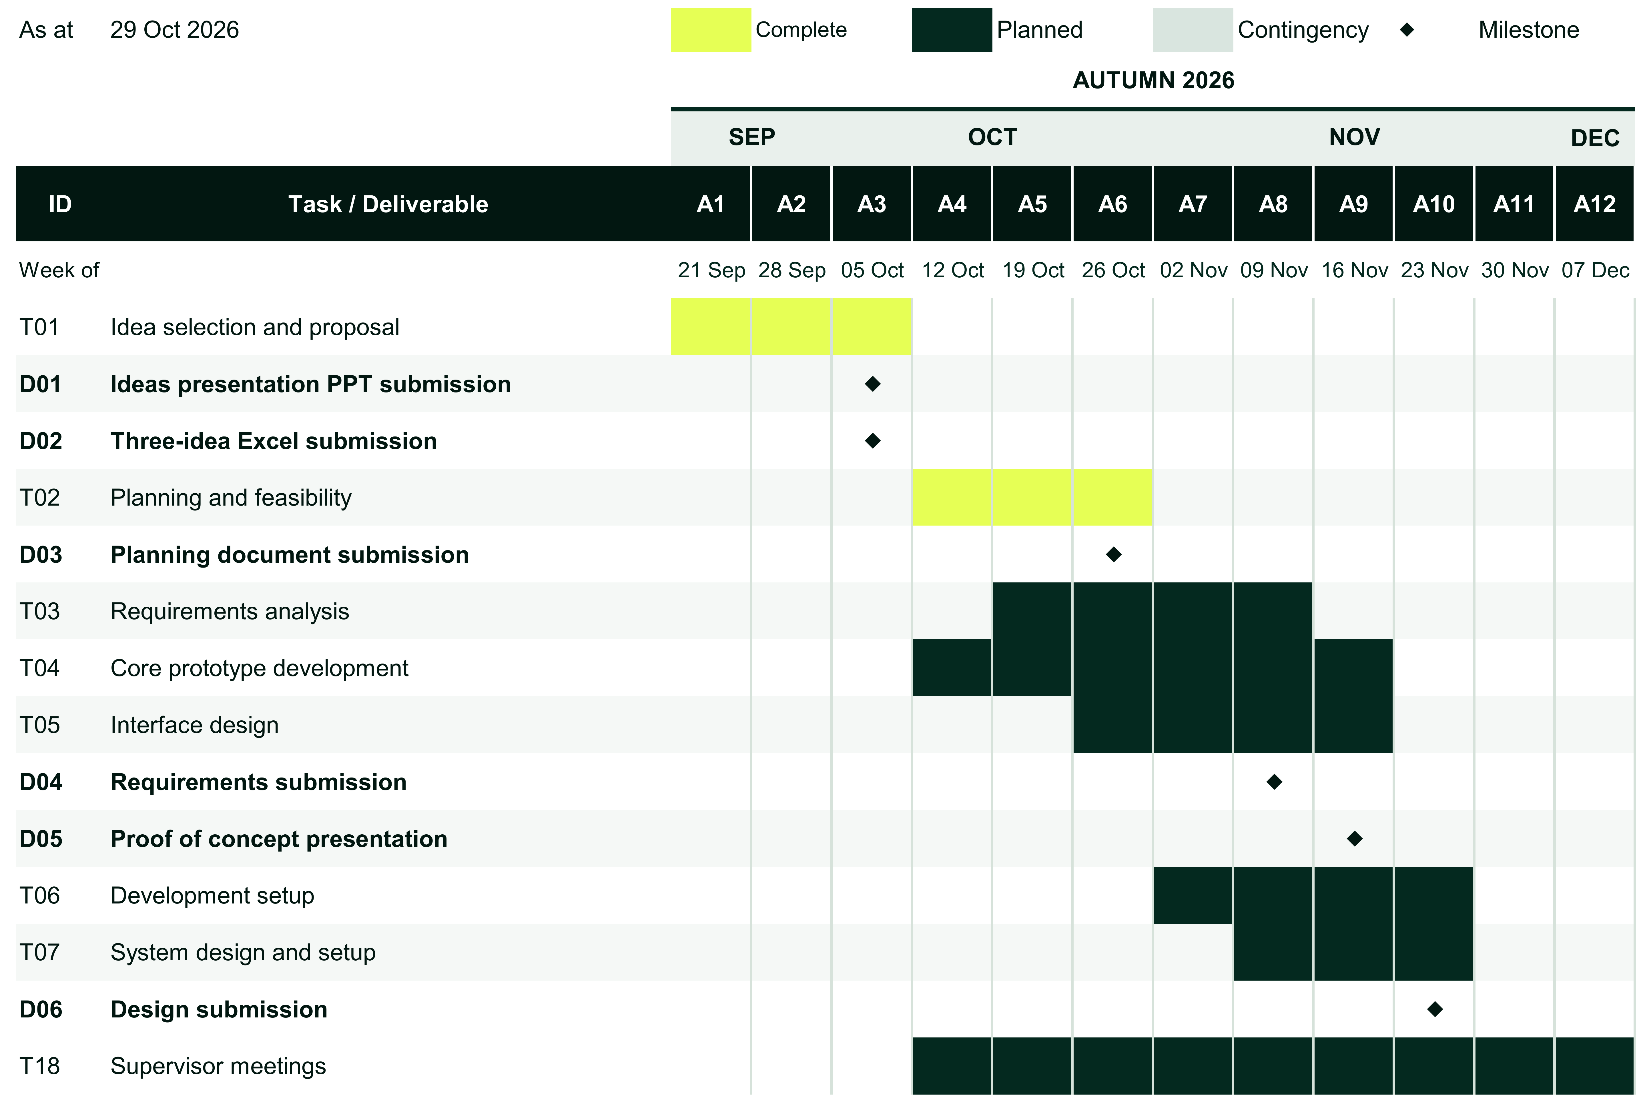
Figure 9.1 Autumn 2026 project schedule

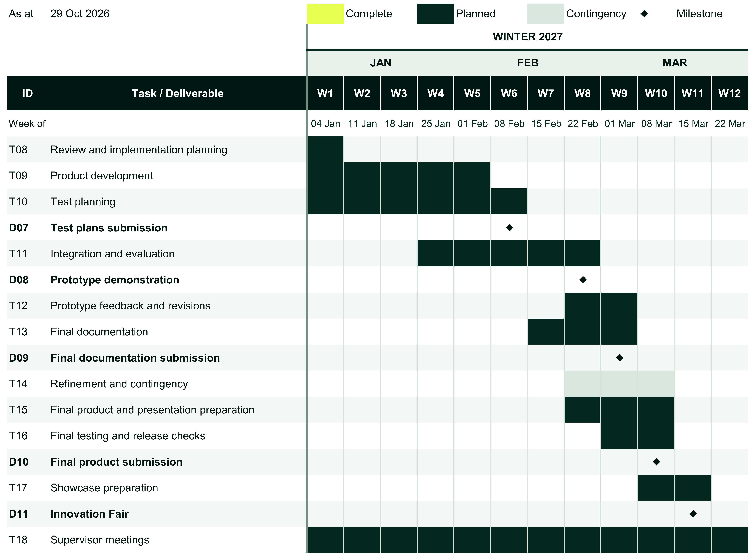
Figure 9.2 Winter 2027 project schedule

Dates beneath week numbers are Monday start dates. The teaching-week timeline excludes the semester break. The Winter 2027 milestones are shown by assessment week as the exact submission dates are yet to be confirmed. Completed bars retain their planned time slots.

9.2 Project Management Approach and Tools
Our team plans to use short development cycles within the Gantt schedule, reviewing progress each week. The first priority is a working Python workflow connecting scanning, controlled verification, patch generation, and testing. Interface work can proceed alongside it, using agreed data formats. This will give us an early opportunity to find integration problems before extending the workflow to other languages.
The Excel-based Gantt Chart will track the overall schedule. A shared task register will record each task’s owner, expected output, dependencies and status, using the same task and deliverable IDs as the chart. We will mark work complete when its output has been reviewed and any blocking issues resolved. If a task slips, we will identify which work is affected down the line and agree a revised action and target week. The refinement period provides some allowance for rework, but we will review delays as they arise.
We meet our supervisor weekly, a routine that began in Autumn Week 4. During the meetings, we discuss progress, receive feedback and review the returned meeting minutes. We then assess the suggestions and incorporate relevant changes into our deliverables. Diaries and progress records form part of this routine. Follow-up actions will have an owner and target date, and we will check their status before the next meeting.
We use a shared online folder to maintain our project documentation, references, and meeting records, alongside a shared online document for each written deliverable. We will continue this approach across both semesters, using Word for final formatting checks. For development we plan to use Git branches and have another team member review changes before they are merged. The task register will link to the relevant deliverable, commit or test record so that progress and individual contributions can be traced.
Before each submission, we will check the deliverable against the assessment requirements and the agreed project scope. Proposed changes to features, language coverage or component interfaces will be reviewed for their effect on the workload, cost, and dependent tasks. We will record each decision, seek supervisor guidance where needed, and update the affected documents and schedule. This will help keep our deliverables consistent as the project develops through both semesters.

9.3 Team Responsibilities and Contributions
We have divided product development into the five work packages in Table 9.1. Each package has a defined output for the other components to use. We will allocate task owners and reviewers in the shared task register as development work is assigned, allowing the team to balance the workload without losing individual accountability.
Table 9.1 Proposed development work packages
Work package | Autumn focus | Winter focus | Key handoff
Scanning and analysis | Build Python scanning and a common format for findings. | Extend scanning and language detection to the other target languages. | Findings with vulnerability type, language and source location.
Sandbox and verification | Build controlled Python execution and targeted verification checks. | Add language-specific containers and connect playground execution. | Verification results and logs for unpatched and patched code.
AI patch generation | Define structured outputs and the Python patch workflow. | Adapt patch generation and retries to language-specific test feedback. | Patch diffs, attempt history and unresolved errors.
Testing and evaluation | Prepare the Python test runner and evaluation criteria. | Add test runners and evaluate the selected Python and JavaScript cases. | Baseline and patched test results, with evaluation measures.
Application and integration | Develop the interface prototype, backend structure and data storage setup. | Connect the dashboard, review tools, playground and approved pull-request workflow. | An integrated review workflow with stored findings and run history.

These work packages depend on one another, so we will coordinate their integration throughout development.
For example, scan findings must contain the information needed for vulnerability verification and patch generation, while verification and test results must be available for the developer’s review. Before connecting components, the team members responsible will agree on the data exchanged and check it using a working example. Setup instructions and known limitations will accompany each handoff, with integration issues revolved jointly.

10 Future Improvements and Conclusion
With PatchGuard, we aim to make vulnerability remediation easier to assess by bringing scan findings, targeted verification, proposed patches and test results into one review workflow. Its value will depend on the quality of that evidence. A passing test suite only covers the behaviour it checks, so developer review will remain part of the process before a proposed repair is taken forward.
We have limited the planned scope to six languages: Python, JavaScript, TypeScript, PHP, Ruby, and Go. This sets a boundary on the development and testing workload across two semesters. Future versions could extend coverage to languages such as Java and C#, with suitable analysis rules, build environments and test runners. Supporting C and C++ would require additional attention to memory-related faults and further verification methods. Each extension would need evaluation on representative projects before we could make claims about its reliability.
A further priority would be broader evaluation within the languages already covered. The planned initial evaluation focuses on Python and JavaScript repositories; its results will not establish equivalent repair quality across all of the supported six languages. Later work could examine more frameworks, larger applications and a wider range of vulnerability cases. Recording failed repairs and environment-setup problems alongside successful runs would help us identify which parts of the workflow need improvement.
Our group’s planning has established the intended scope, work packages, and route to delivery. The next step is to test the central workflow on a repeatable Python example: reproduce a finding, generate patch, repeat the verification check and compare application-test results before and after the change.
This will provide evidence for the technical approach and help refine effort and cost estimates before wider integration. We will use those findings to review the plan and report the system’s demonstrated capabilities and remaining limitations.

11 Report Work Distribution
Table 11.1 records our section responsibilities for this Planning and Feasibility Analysis Document. Each author is responsible for drafting the allocated sections, supplying supporting references and addressing review comments.
Table 11.1 Report writing responsibilities
Member | Sections | Report responsibility
Sibi | 1–2 | Background and Problem Statement; Project Description and Objectives.
Yahya | 3–4 | Competitor Analysis and Business Case; Project Scope.
Hriday | 5–6 | System Overview; Software and Hardware Requirements.
Wissam | 7–8 | Feasibility Analysis; Challenges and Risk Management.
Bilal | 9–10 | Project Plan and Work Distribution; Future Improvements and Conclusion; report assembly.

References
Bessey, A., Block, K., Chelf, B., Chou, A., Fulton, B., Hallem, S., Henri-Gros, C., Kamsky, A., McPeak, S.
and Engler, D. (2010) ‘A few billion lines of code later: using static analysis to find bugs in the real world’, Communications of the ACM, 53(2), pp. 66–75. Available at: https://doi.org/10.1145/1646353.1646374 (Accessed: 24 October 2026).
Christakis, M. and Bird, C. (2016) ‘What developers want and need from program analysis: an empirical study’, in Proceedings of the 31st IEEE/ACM International Conference on Automated Software Engineering (ASE 2016). Singapore, 3–7 September. New York, NY: ACM, pp. 332–343. Available at: https://doi.org/10.1145/2970276.2970347 (Accessed: 24 October 2026).
Edgescan (2023) 2023 Vulnerability Statistics Report. 8th edn. Dublin: Edgescan. Available at: https://www.edgescan.com/wp-content/uploads/2024/03/2023-Vulnerability-Statistics-Report.pdf (Accessed: 24 October 2026).
GitHub (n.d.a) About autofix for code scanning. Available at: https://docs.github.com/en/code-security/concepts/code-scanning/autofix-for-code-scanning (Accessed: 20 October 2026).
GitHub (n.d.b) Application card: GitHub security and quality AI features. Available at: https://docs.github.com/en/enterprise-cloud@latest/code-security/responsible-use/security-and-quality-ai-features (Accessed: 20 October 2026).
GitHub (n.d.c) Dependabot security updates. Available at: https://docs.github.com/en/code-security/concepts/supply-chain-security/dependabot-security-updates (Accessed: 24 October 2026).
Jimenez, C.E., Yang, J., Wettig, A., Yao, S., Pei, K., Press, O. and Narasimhan, K. (2024) ‘SWE-bench: can language models resolve real-world GitHub issues?’, in Proceedings of the 12th International Conference on Learning Representations (ICLR 2024). Vienna, Austria, 7–11 May. Available at: https://openreview.net/forum?id=VTF8yNQM66 (Accessed: 24 October 2026).
Sadowski, C., Aftandilian, E., Eagle, A., Miller-Cushon, L. and Jaspan, C. (2018) ‘Lessons from building static analysis tools at Google’, Communications of the ACM, 61(4), pp. 58–66. Available at: https://doi.org/10.1145/3188720 (Accessed: 24 October 2026).
Semgrep (2026a) ‘Accelerate remediation with Semgrep Autofix’, Semgrep Product Updates, 16 March. Available at: https://semgrep.dev/products/product-updates/accelerate-remediation-with-semgrep-autofix/ (Accessed: 20 October 2026).
Semgrep (2026b) Usage and billing. Last updated 30 April 2026. Available at: https://semgrep.dev/docs/usage-limits/ (Accessed: 20 October 2026).
Snyk (n.d.a) How Snyk incorporates generative AI into the platform. Available at: https://docs.snyk.io/snyk-data-and-governance/how-snyk-incorporates-generative-ai-into-the-platform (Accessed: 20 October 2026).
Snyk (n.d.b) Snyk PR checks in your pull request/merge request. Available at: https://learn.snyk.io/lesson/checking-your-code-with-pr-checks/ (Accessed: 20 October 2026).
Snyk (n.d.c) Supported languages, package managers, and frameworks. Available at: https://docs.snyk.io/supported-languages/supported-languages-package-managers-and-frameworks (Accessed: 20 October 2026).
Veracode (2024) State of software security 2024: addressing the threat of security debt. Burlington, MA: Veracode. Available at: https://www.veracode.com/wp-content/uploads/2024/06/SOSS-Report-2024.pdf (Accessed: 24 October 2026).

